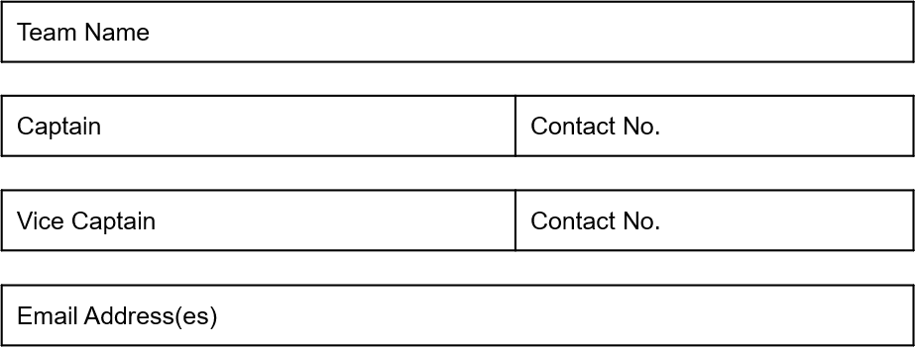

What division / Leagues do you currently play in?

**ENTRANCE FEE - £120 per team.**

Closing date for all entries: **11th August 2022**

**Tournament Date Sunday 11/09/2022**

Please forward the completed Booking Form with your non-refundable deposit of £20 or payment in full to:

The League - Account Number: 33728941 Sort code: 60-40-09

Alternatively, payment can be made in person to THE League Co-Ordinator at Goals on Monday evening match nights, or full payment can be made on tournament day if you are a current The League Team

Please make cheques payable to ‘***The League’***

**PLEASE NOTE:**

**By signing up to this event, teams confirm that they are responsible for their own insurance and medical cover, The League Netball will not be liable for injuries, first aid or any other incidents that take place during participation in the event by any player, coach or official.**

Thank you for your entry, we look forward to hosting you for a great day of netball!!!

**Team Details: (please tick 1 box only)** Mixed Ladies

‘The Cath Askwith Multi Netball Tournament’

Booking Form