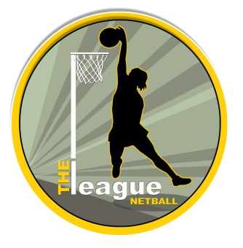
Phone: 07875 738959 Janice
Phone: 07891 891237 Jess
E-mail:leaguenetball@yahoo.co.uk
Web: www.theleaguenetball.co.uk
The League
85 High Street
Killamarsh
Sheffield
S21 1BJ

UMPIRES THE LEAGUE NHS TEST AND TRACE WITHIN NETBALL
All information to be obtained and stored for a minimum of 21 days by THE League COVID-19 Leads
All named individuals are not displaying symptoms and have not been in contact/live with anyone displaying symptoms within 7 days prior to dated netball activity and have undertaken the personal health screening & declaration.
All named individuals participating in the dated netball activity understand the risks with participating in netball.
Information to be collected in advance of each netball activity or before mixes with others.
Umpires - Please inform THE League COVID-19 Leads of any attendee who has developed COVID-19 symptoms up to 48hours after dated The League netball activity, reported to NHS Test and Trace and tested positive.

WESTFIELD SPORTS CENTRE OUTDOOR COURTS - UMPIRES
Date | Court Number | Match Start Times | Umpire Name | Umpire Contact Details

